University Research Repository System
1. Project Title
University Research Repository System
2. Introduction
University Research Repository System is a backend application developed using Java, Spring Boot, and MongoDB to manage and organize academic research information within a university. The system provides a centralized platform for storing and managing departments, researchers, research papers, publications, and reviews. It enables efficient management of research records through REST APIs while maintaining proper relationships between entities. The application uses MongoDB for data storage and Spring Boot for backend development..

3. Project Objective
The objective of this project is to develop a centralized repository for managing university research activities. The system allows administrators to create, view, update, and delete information related to researchers, departments, research papers, publications, and reviews. It demonstrates CRUD operations, REST API development, MongoDB integration, and implementation of One-to-One, One-to-Many, and Many-to-Many relationships using Spring Boot and MongoDB.

4. Problem Statement
Universities generate a large amount of research data, including research papers, publications, and researcher information. Managing this information manually can be difficult and may lead to data duplication, inefficient record keeping, and difficulties in tracking research contributions. This project provides a digital platform that simplifies research management by organizing research data in a structured and centralized manner..

5. Technology Stack
Component | Technology
Programming Language | Java 25
Framework | Spring Boot 3.5.x
Database | MongoDB 8.3
IDE | IntelliJ IDEA 2026.1.2
Build Tool | Maven 11.x
API Testing | Postman 3.9x
Database GUI | MongoDB Compass

6. System Architecture
Admin
|
▼
Postman / Swagger
|
▼
REST Controllers
|
▼
Service Layer
|
▼
Repository Layer
|
▼
MongoDB

7. Modules of the System
- Department Module
- • Add Department
• View Department
• Update Department
• Delete Department
• View Department Papers
- Researcher Module
- • Add Researcher
• View Researcher
• Update Researcher
• Delete Researcher
• Assign Research Papers
- Research Paper Module
- • Add Research Paper
• View Research Paper
• Update Research Paper
• Delete Research Paper
• Assign Review
• Assign Researchers
- Publication Module
- • Add Publication
• View Publication
• Update Publication
• Delete Publication
- Review Module
- • Add Review
• View Review
• Update Review
• Delete Review

8. Database Design
Collection: Department
Fields
departmentId
departmentName
departmentCode
Collection: Researcher
Fields
researcherId
name
email
designation
Collection: ResearchPaper
Fields
paperId
title
abstractText
keywords
publicationYear
departmentId
reviewId
researcherIds
Collection: Publication
Fields
publicationId
publicationName
publisher
impactFactor
Collection: Review
Fields
reviewId
reviewerName
rating
remarks

9. Relationship Mapping
One Department → Many Research Papers
Department (1) ---> ResearchPaper (M)
One Research Paper → One Review
ResearchPaper (1) ---> Review (1)
Many Researchers ↔ Many Research Papers
Researcher (M) <--> ResearchPaper (M)

10. CRUD Operations
- Create
- • Add Department
• Add Researcher
• Add Research Paper
• Add Publication
• Add Review
- Read
- • View Departments
• View Researchers
• View Research Papers
• View Publications
• View Reviews
- Update
- • Update Department
• Update Researcher
• Update Research Paper
• Update Publication
• Update Review
- Delete
- • Delete Department
• Delete Researcher
• Delete Research Paper
• Delete Publication
• Delete Review

11. Server Configuration
server.port=8080
spring.data.mongodb.uri=mongodb://localhost:27017/research_repository_db

12. REST API Endpoints
GET /departments/{id}/papers
GET /researchers/{id}/papers
POST /papers/{paperId}/researchers/{researcherId}
DELETE /papers/{paperId}/researchers/{researcherId}
POST /papers/{paperId}/review/{reviewId}

13. Project Structure
src/main/java
com.researchrepository
├── controller
├── service
├── repository
├── model
├── dto
├── exception
├── config
└── ResearchRepositoryApplication.java

14. API Testing
All APIs will be tested using Postman and Swagger. CRUD operations, relationship mappings, validation, and database connectivity will be verified through REST API requests and responses.

15.Output Screenshot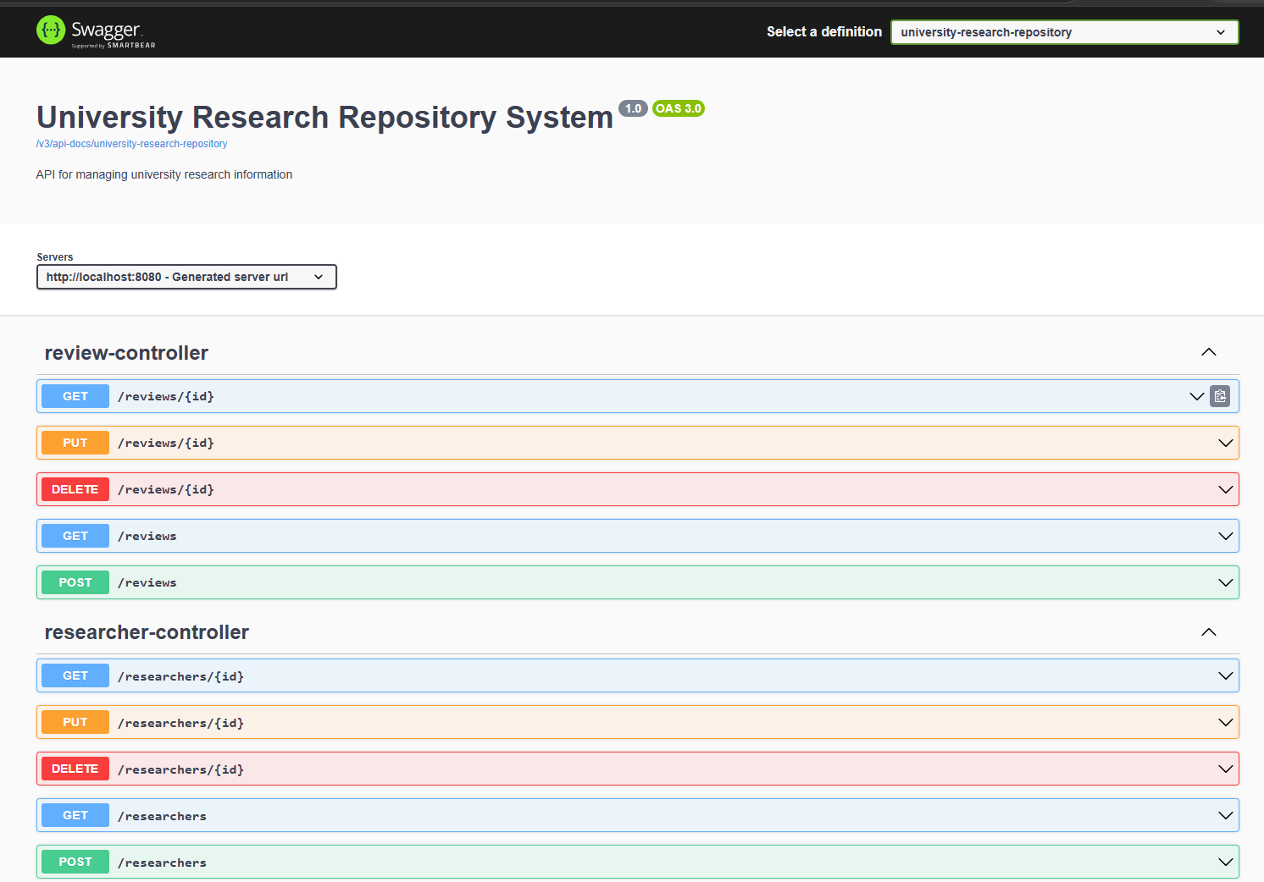
Spring Running-
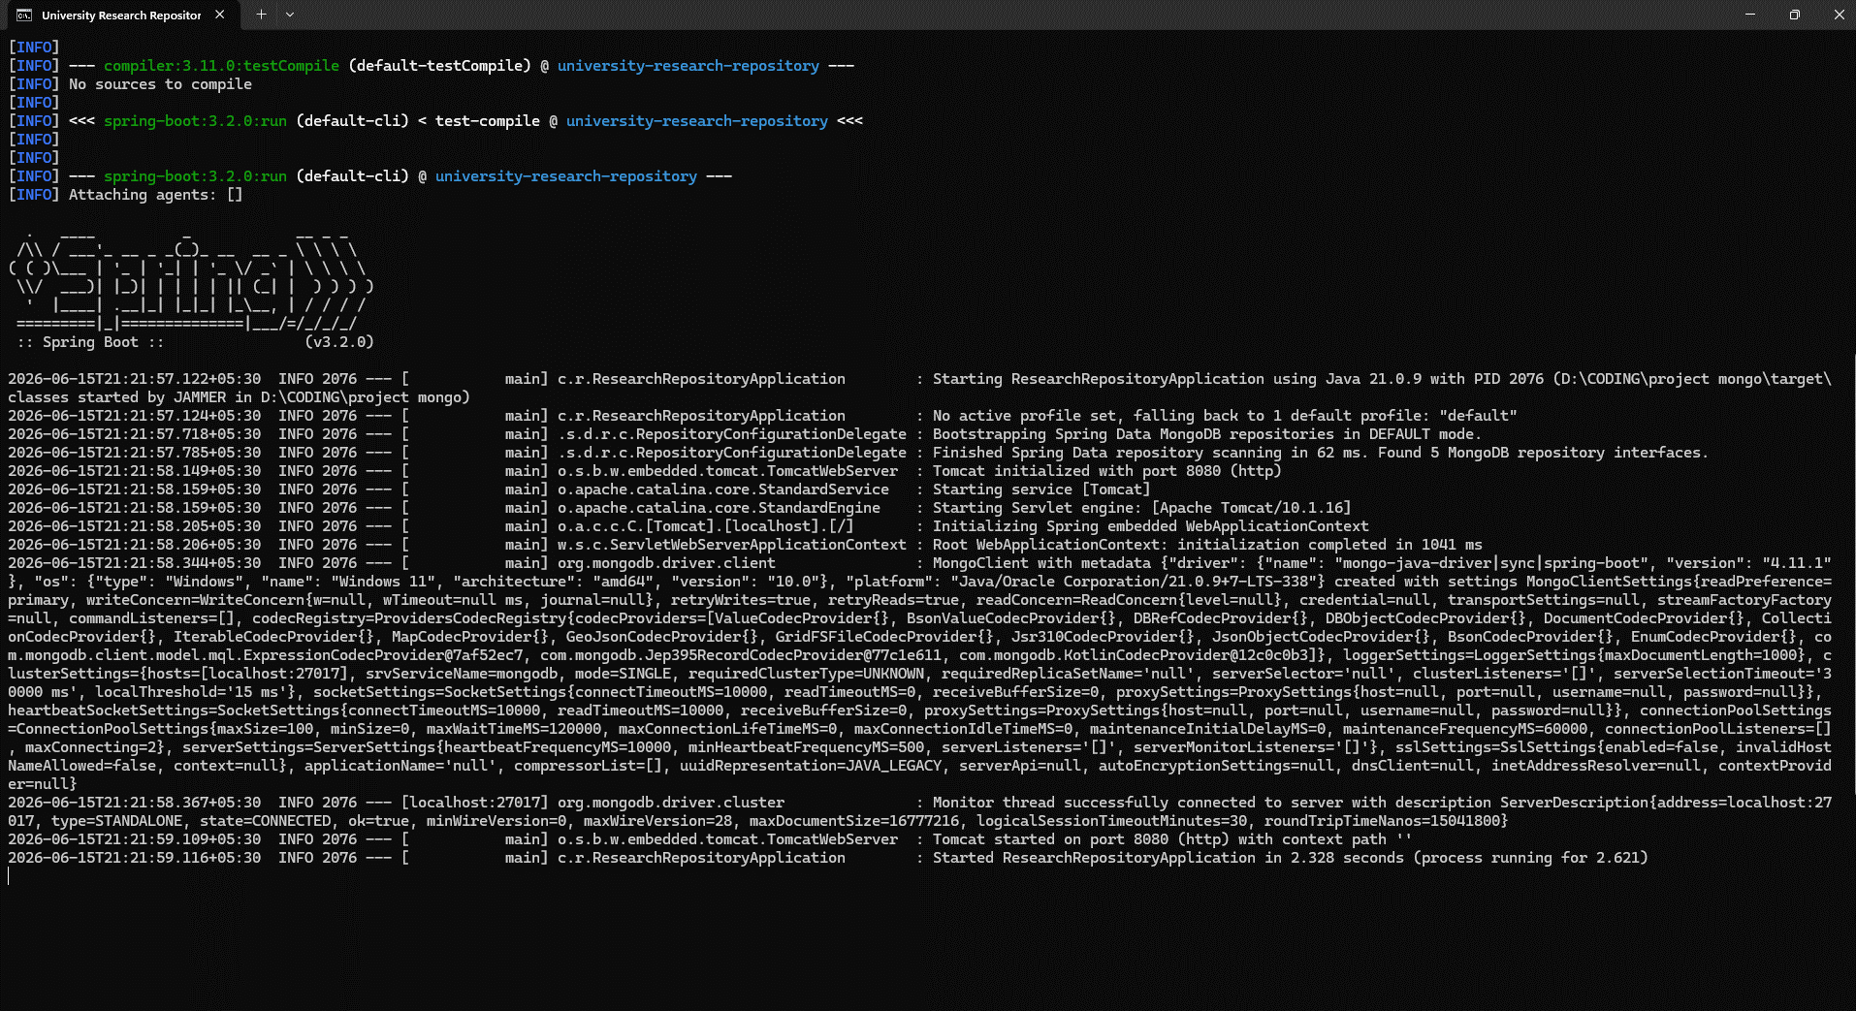
Postman Response
1.Create Department
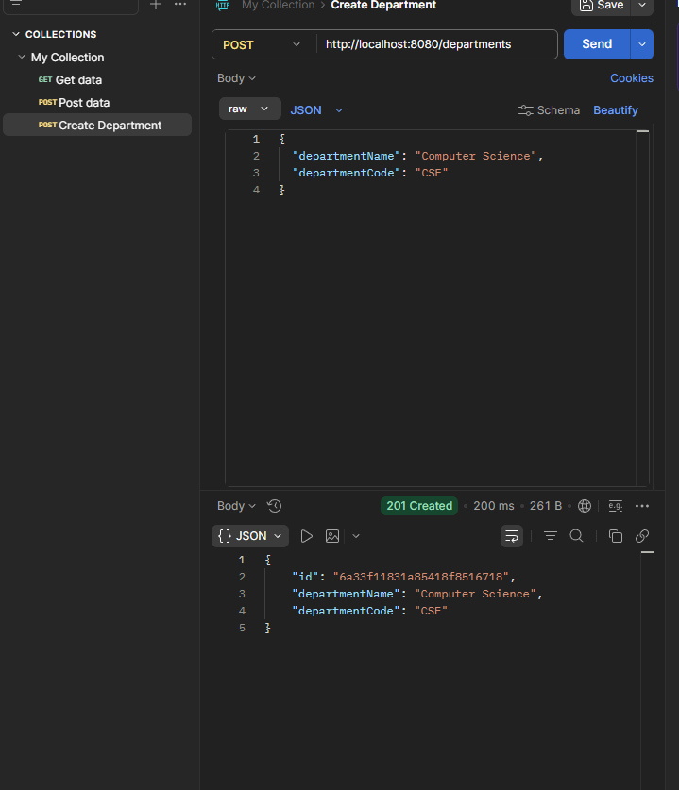
Get All Departments
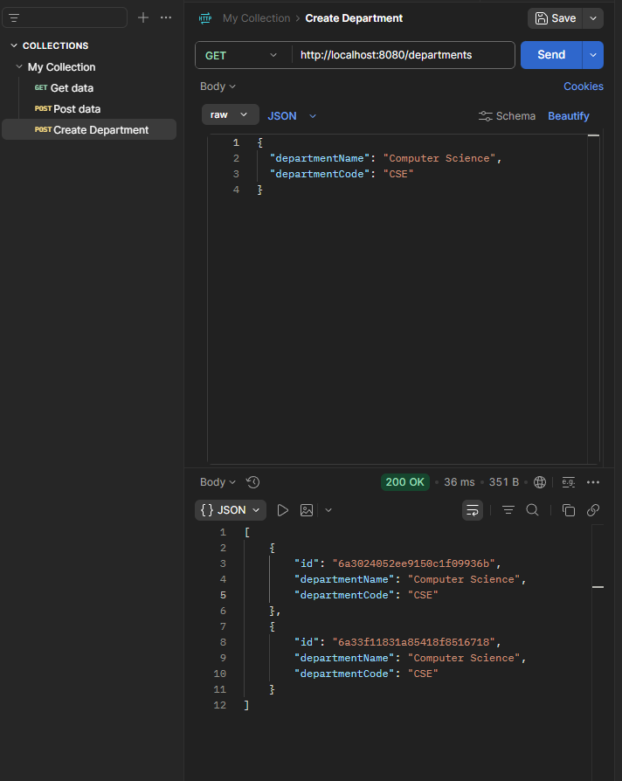
Update Department

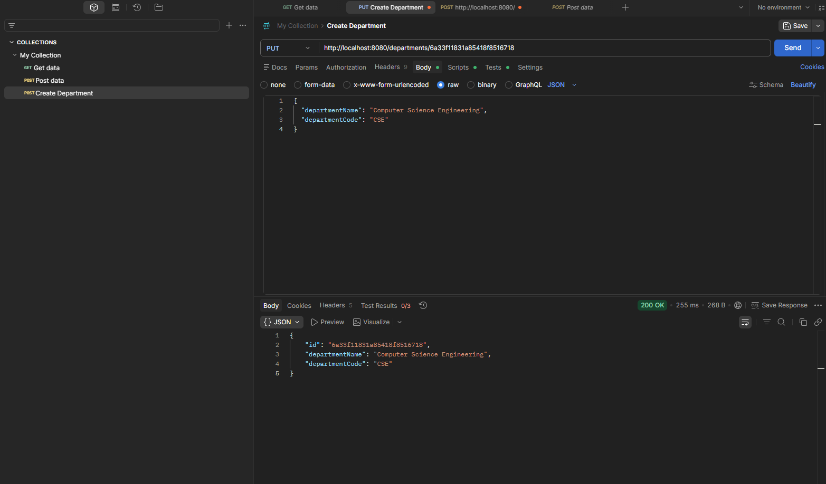
Delete Department
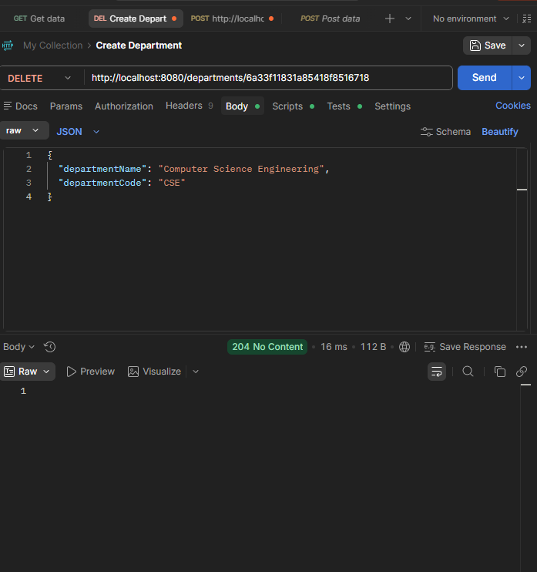
MONGODB
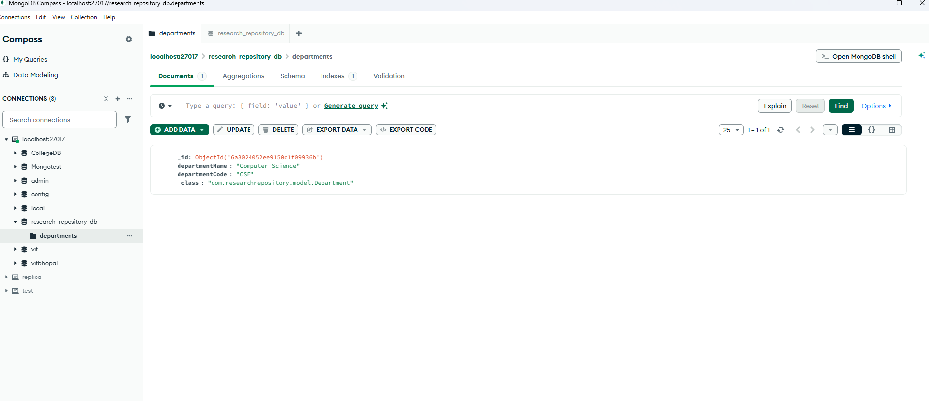

16. Expected Outcomes
Centralized research data management
• Efficient storage of research papers
• Easy researcher and publication management
• Improved organization of academic records
• Better tracking of research contributions
• Simplified retrieval of research information
17. Future Enhancements
JWT Authentication
• Role Based Access Control
• Research Paper File Upload
• Advanced Search Functionality
• Analytics Dashboard
• Email Notifications
• Frontend Integration
18. Conclusion
The University Research Repository System provides a centralized platform for managing academic research information. Using Spring Boot, MongoDB, Swagger, and Postman, the project demonstrates REST API development, CRUD operations, database relationships, validation, and backend application architecture. The system improves the management of research data while providing practical exposure to modern backend technologies and software development practices.

